# Department of Computing

# EE353: Computer Networks

# Class: BESE

**CLO 2: Apply the knowledge of Computer networking to understand contemporary networking issues**

**Lab 5: Configuration of DHCP Server**

**Date: 11-10-2023**

# Time: 10:00 to 12:00 and 2:00 to 05:00

**Course Instructor’s: Dr Huma Ghafoor**

**Lab Engineer: Syed Muhammad Ali Musa**

**Name:** Aimen Munawar

**Class:** BESE-13-A

**CMS ID:** 415867

**Lab 5: Configuration of DHCP Server**

**Introduction**

A DHCP Server is a network server that automatically provides and assigns IP addresses, default gateways and other network parameters to client devices. It relies on the standard protocol known as Dynamic Host Configuration Protocol or DHCP to respond to broadcast queries by clients.

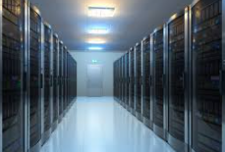

**Objectives**

Configuration of DHCP Server

**Tools/Software Requirement**

CISCO Packet Tracer

**Description**

A DHCP Server is a network server that automatically provides and assigns IP addresses, default gateways and other network parameters to client devices. It relies on the standard protocol known as Dynamic Host Configuration Protocol or DHCP to respond to broadcast queries by clients.

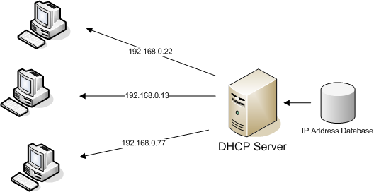

**Lab Task:**

DHCP is normally used to assign a computer its IP address, as well as other parameters such as the address of the local router. Your computer, the client, uses the DHCP protocol to communicate with a DHCP server on the local network. Other computers on the local network also interact with the DHCP server. Your task in this lab is to configure DHCP on a Server and Router in Cisco Packet Tracer. You can increase or decrease end devices. At the end every end device will get the dynamic ip address from DHCP server.

**Hint:** [**https://youtu.be/QH2RXL0sWf8?si=HsCgdcJSehaJbQ52**](https://youtu.be/QH2RXL0sWf8?si=HsCgdcJSehaJbQ52)

**Method 1:**

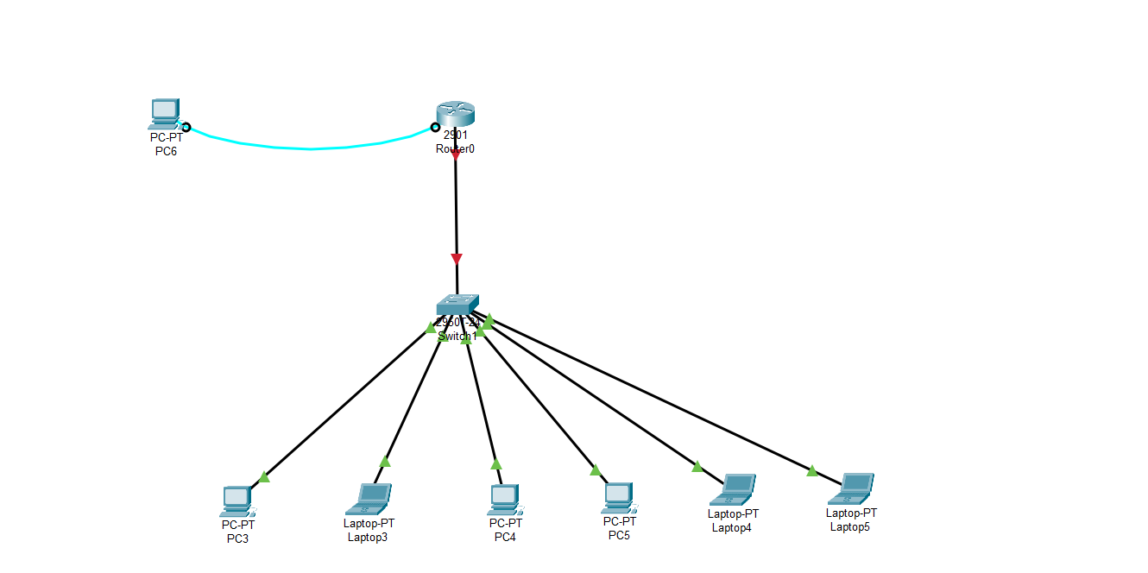

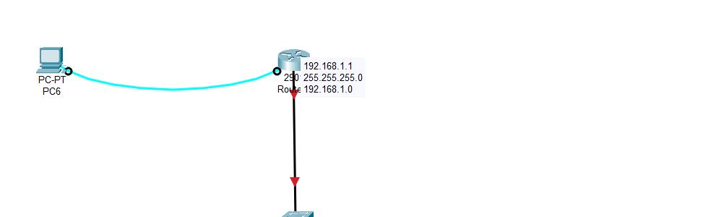

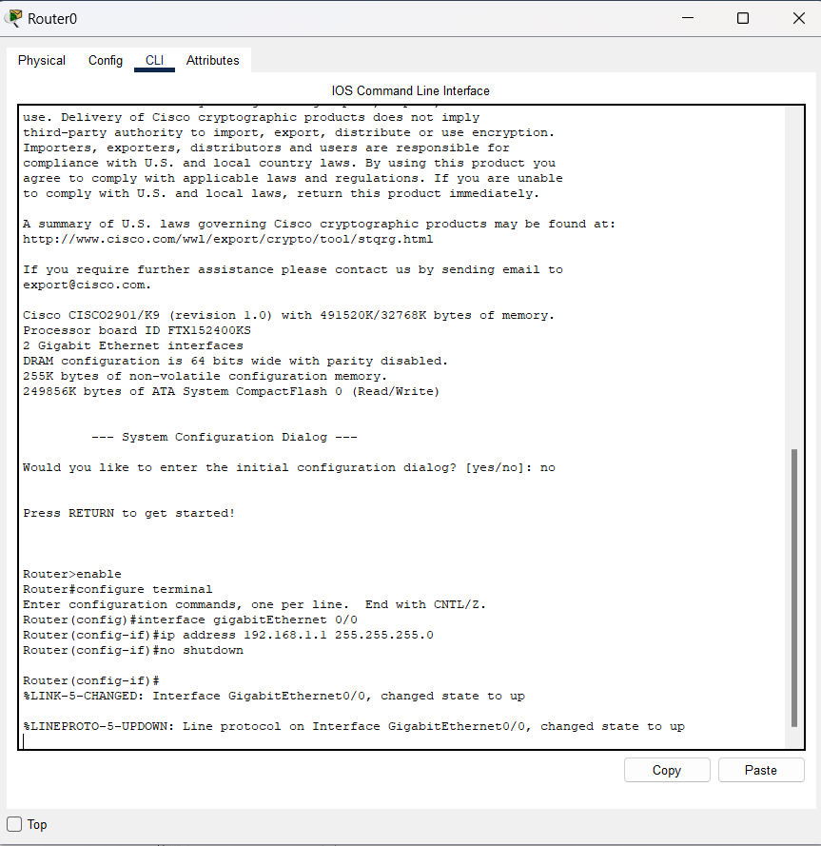

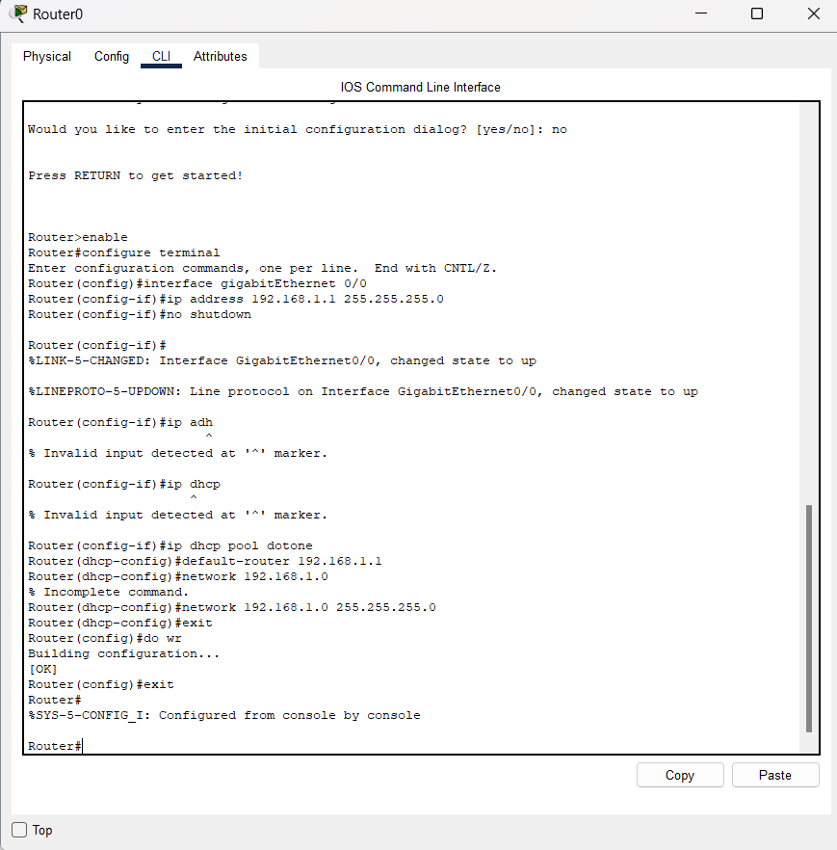

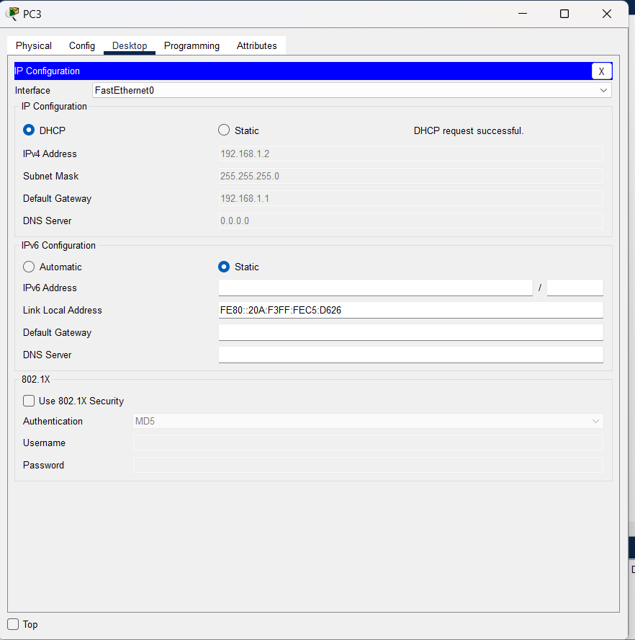

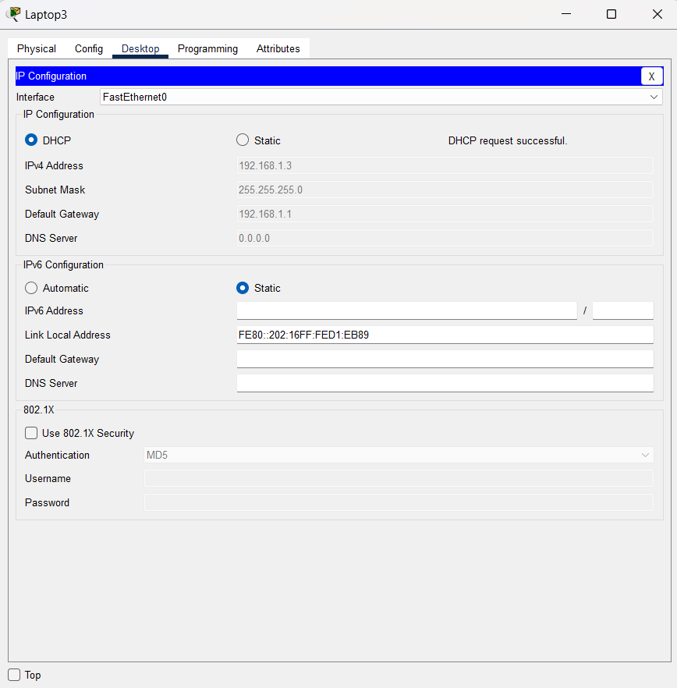

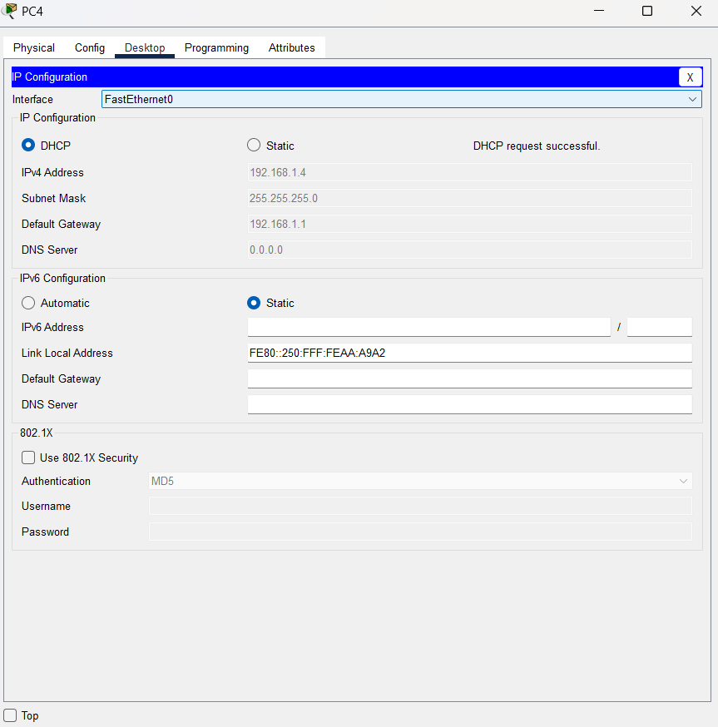

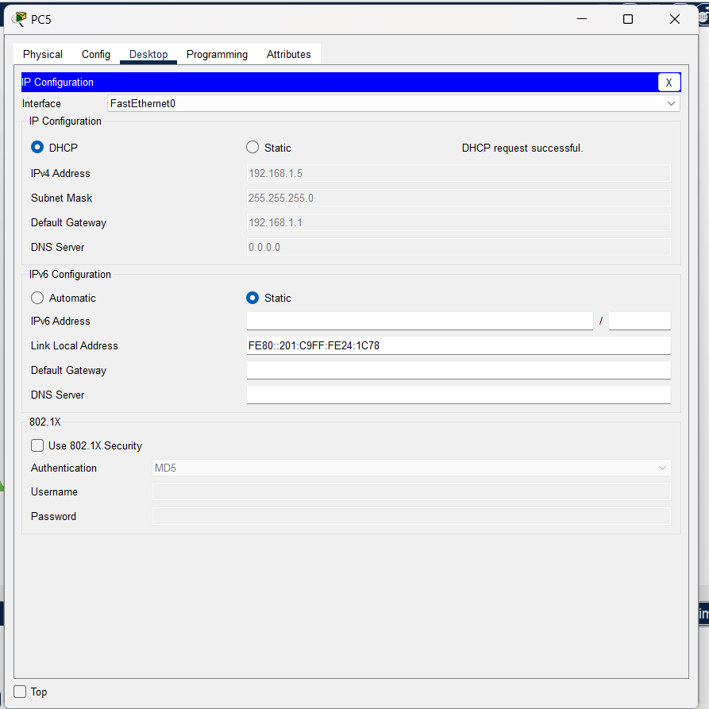

**Method 2:**

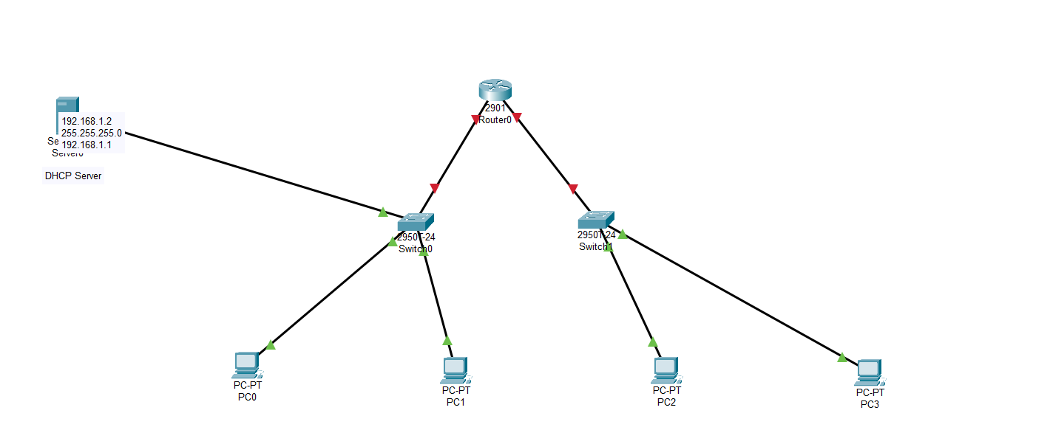

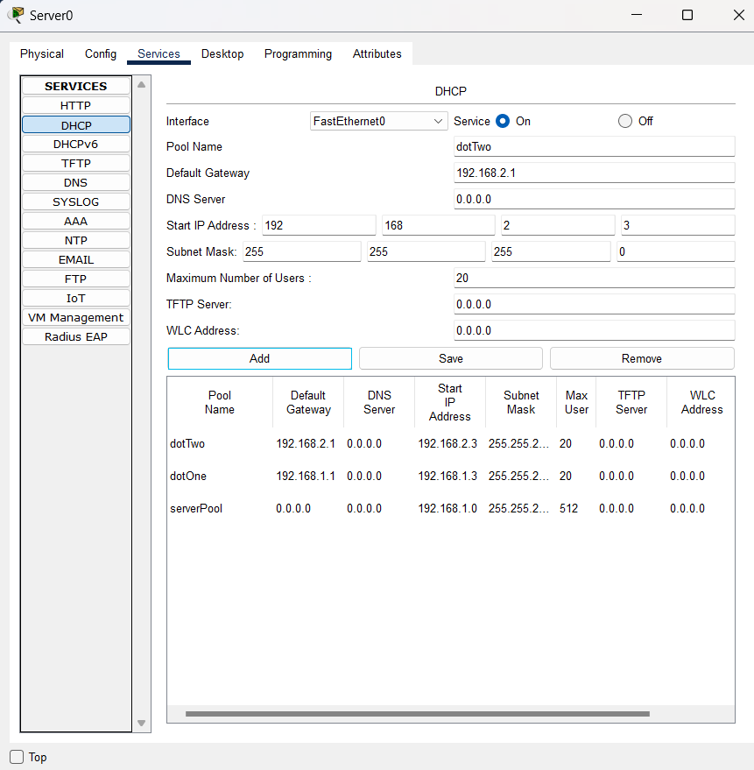

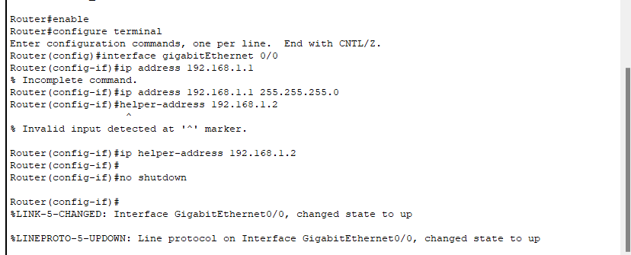

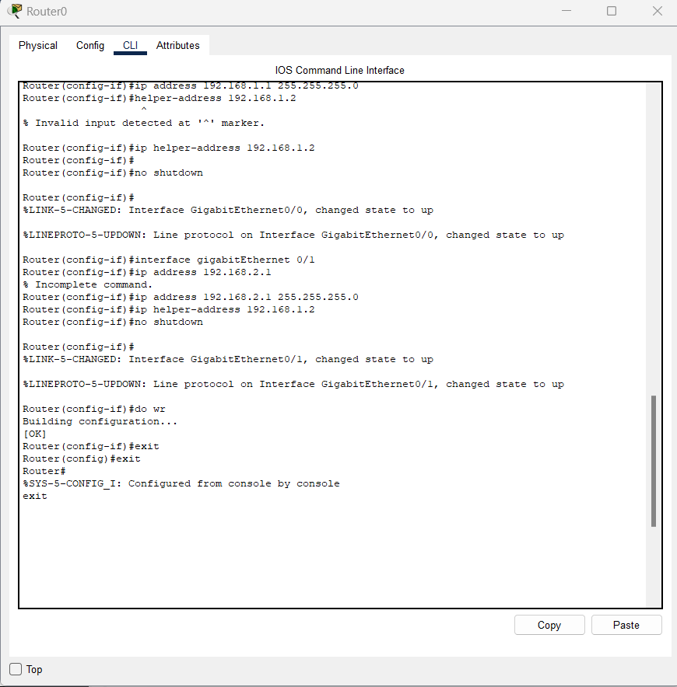

**Deliverables**

Zip and Upload all .pkt files

**Grade Criteria**

This lab is graded. Min marks: 0. Max marks: 10.

|  |  |  |
| --- | --- | --- |
| **Activity** | **Minimum** | **Maximum** |
| Documentation with clearly defined understanding of the lab task and approach | Fail | Pass |
| Lab Tasks | 0 | 10 |